Pizza Dough
2 packages active dry yeast
2 1/2 cups warm water (105-155 degrees F/40-46 degrees C)
2 tsp. granulated sugar
1/4 cup olive oil
5 cups bread flour, plus extra as needed
1 Tbs. Salt
All-purpose flour for rolling and shaping

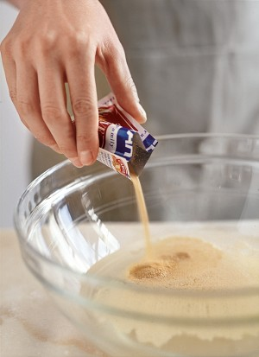
Proof the yeast
Pour the yeast into the warm water in a bowl and gently stir until the yeast dissolves.
Let the yeast and water stand until foamy, about 5 minutes. (If the yeast doesn’t foam, it is either inactive of you have used water that is too cold or too hot; start over with fresh yeast.)

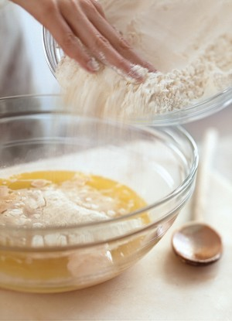
Add the other ingredients
When you have determined that the yeast is active, add the sugar, oil, flour and salt. The salt will kill the yeast if it comes in direct contact with it, so make sure to add the salt last.

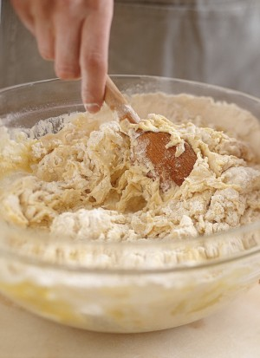Mix the dough
Using a wooden spoon or your hands, stir the dough until it forms a rough mass. Using a plastic pastry scraper, scrape the dough onto a lightly floured work surface.

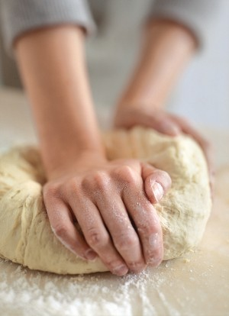
Knead the dough
Knead the dough until soft, smooth and elastic, 8 to 10 minutes, adding flour to the work surface as needed to prevent the dough from sticking to it.

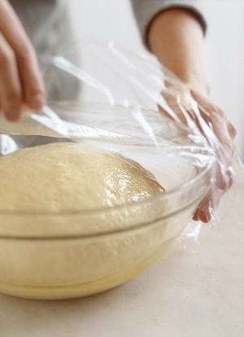
Let the dough rise
For the dough into a ball and transfer it to a clean, lightly oiled bowl. Cover the bowl with plastic wrap or a clean kitchen towel. Let the dough rise in a warm, draft-free spot until it doubles in bulk, 1 1/2 to 2 hours. (Alternatively, place the covered bowl in the refrigerator overnight. Let the dough come to room temperature before shaping.)

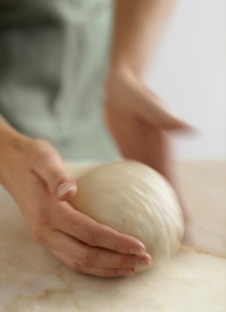
Divide and shape the dough
Turn the dough out of the bowl onto a lightly oiled work surface. Cut it in half with a sharp knife or bench scraper. Gently shape each half into a loose ball by moving the dough in a circle and pushing the sides down toward the bottom so that the ball tightens a little.

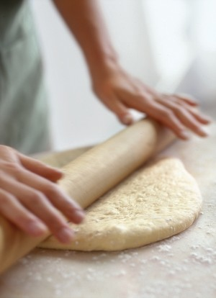
Roll out the dough
Cover one of the dough balls with a damp towel. Lightly dust the other dough ball with all-purpose flour. Using a rolling pin or your hands, roll or stretch the dough into a 12- to 14-inch (30- to 35-cm.) round and transfer to a baker’s peel or the top of an inverted baking pan. Top the pizza dough as desired and bake using the directions at right, or according to your recipe. Repeat with the remaining dough ball. Makes two 12- to 14-inch (30- to 35-cm.) pizza crusts.

