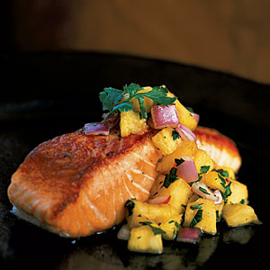
Sweet and Spicy Salsa

8 Roma Tomatoes, diced

1 whole Pineapple (must be fresh), diced

1 Green pepper, diced

½ of Red onion, diced

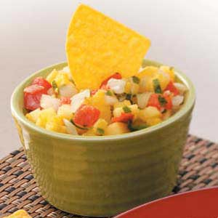
3 T. Cilantro, minced

1 Jalapeño, brnoise

Lime juice (1/2 of the lime)

Add seasoning to taste: salt, pepper, garlic powder, & Cajun season

- Wash all vegetables in cold water.
- Drain in a colander.

- Cut all ingredients

- Mix in a large bowl.

- Add seasoning to taste

- Serve with chips.

- Leftover need to be refrigerated (it will be even better tomorrow).

